†

LUISA PICCARRETA CENTER FOR THE DIVINE WILL

P.O. Box 415, Jacksboro, TN, 37757 – Telephone: 423-566-5178

Divine Will Internet Cenacle**

Theatre of Rounds of Creation

LESSON 300

January 22, 2016

As the soul enters into the Divine Will, there are exchanges of works

and reciprocal love which form moving scenes as to form the Paradise of God and the soul.

Volume 18, January 10, 1926, Page 72, (whole chapter)

The Divine Actor, prepares the most beautiful scenes in the theatre of creation.

All creation was to serve man.

Volume 15, January 2, 1923, Page 15, (whole chapter)

The six days of creation and the immense void.

Volume 16, August 1, 1923, Page 4, (whole chapter)

All creation brings us the “I LOVE YOU” of Jesus.

Volume 15, May 25, 1923, Page 60, (whole chapter)

All creation was made to be a gift to the legitimate sons and daughters.

Volume 17, June 3, 1925, Page 131, (whole chapter)

In creation God made a display of all His Works.

Volume 12, April 15, 1919, Page 156, (whole chapter)

Jesus created minor things first, as preparations.

Volume 12, February 20, 1919, Page 132, (whole chapter)

Each created thing is a relation of Grace and Love between God and the creature.

+

Rounds

Theatre of Rounds of Creation
-In Jesus, the Divine Actor who prepares the most beautiful scenes in the theatre of creation, all for man.
-In the creation of the stars, planets, asteroids and meteors and comets.
-In the creation of Light and the Angels who serve God as messengers to man.
-In the creation of the sea and all the waters.
-In the creation of all minerals, plant and animal kingdom.


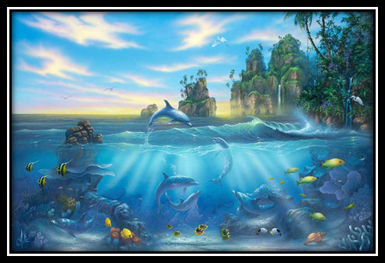
The Theatre of Rounds in Creation

The billions of stars created in the azure sky - The most refulgent light of the sun and its rays -- The majestic creation of the seas and all its inhabitants - The creation of the plants, flowers and bird and animal kingdom. EACH CREATED THING IS AN ‘I LOVE YOU’ TO THE CREATURE.

**These lessons are coming to you from the Desk of Linda Wawryk, British Columbia, Canada, who can be reached at: dwcenacle@live.com.

