Christmas Novena

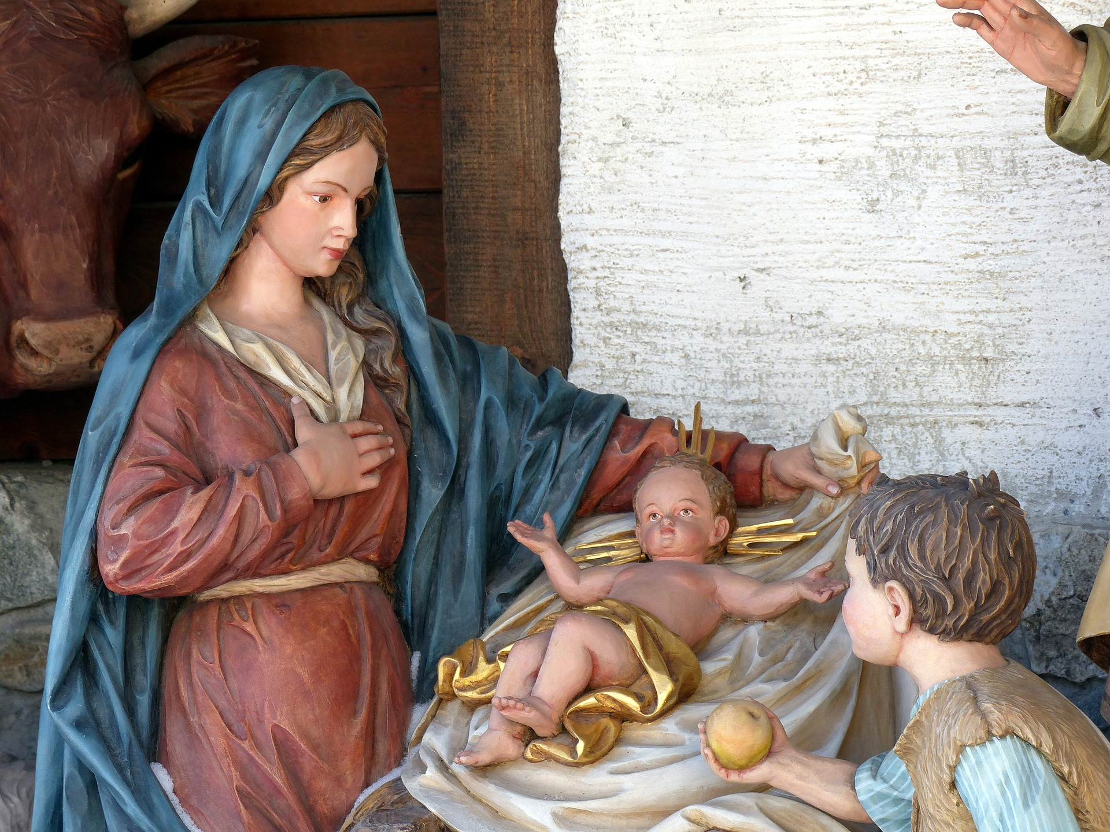
In Your Will and with Your Love, I desire to gather all that You have created out of so much love for mankind, from the beginning of time until the end of time; all souls, all Angels and all Creation, substituting for any and all who would refuse to join me. I bring all Your Creatures and Creation before Your Most Holy and Majestic Throne, and prostrating ourselves, we proclaim our love, adoration, praise, and honor, to glorify You profoundly, pleading through these rounds for Your Kingdom to come:

- In the decisive council of the Most Holy Trinity, wanting to redeem the human race
- In the act of the Father who wants to send his Only-Begotten Son upon the earth
- In the act of the Son assenting to the Father’s desire
- In the act of the Holy Spirit who is pleased to be in His full consent – all for the greater good and salvation of humanity
- In the reciprocal love of the Divine Persons – a love diffused itself for the copious advantage of man.

Volume 1, First Excess

Continuing in Thy Will and with Thy Love, we love you, we adore you, and we glorify you:

- In Baby Jesus residing in the most pure womb of Mary Most Holy, Virgin and Mother
- In the truth that the great God, who cannot be contained by the heavens would, for the Love of man, become so small and restricted as to neither move Himself nor breathe in the maternal womb
- In the plea of Jesus to creatures, “See how much I love you? For pity’s sake, make a little space in your heart for Me. Take out all that is not mine so that it may give Me more ease to move and breathe in your heart.”

Volume 1, Second Excess

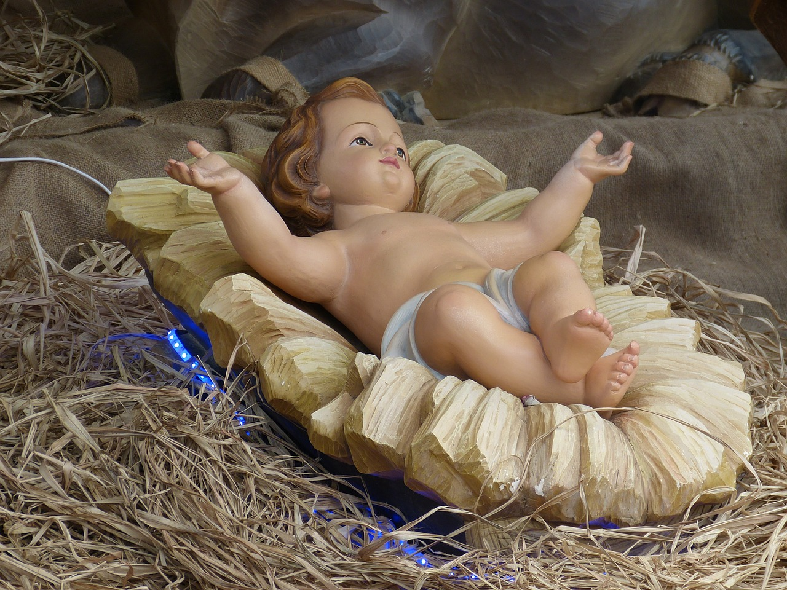

In Thy Will, with Thy Love, we love you, we adore you, and we praise you:

- In the words of the Mass, “O God, who see how your people faithfully await the feast of the Lord’s nativity, enable us, we pray, to attain the joys of so great a salvation and to celebrate them always with solemn worship and glad rejoicing.”
- In the responsorial psalm, “Cry out with joy and gladness: for among you is the great and Holy One of Israel”
- “The Spirit of the Lord is upon me, because he has anointed me to bring glad tidings to the poor”
- “Say to the faint of heart: Be strong and do not fear. Behold, our God will come, and he will save us.”

The Mass of the 3rd Sunday of Advent

In Thy Will, with Thy Love, we love, adore, praise and glorify you:

- In the final doxology, “For the kingdom, the power and the glory are yours now and forever”
- In the first three petitions to our Father: the glorification of His name, the coming of his reign, and the power of his saving will.”
- In the restoration by Christ the Lord to the Father
- In the mystery of salvation that will be brought to its completion and God will be all in all

Catechism of the Catholic Church, 2855

In Thy Will, with thy Love, we are so sorrowful, and we beg pardon:

- For the continuous pain that Jesus receives from creatures
- For those who listen unwillingly to the words of eternal Life
- For those who scorn Jesus’ company and unfetter themselves from His love
- For those who try to escape from Jesus or play deaf so as to reduce Him to silence
- For those who despise and abuse Jesus’ kisses and embraces

Volume 1, Fifth Excess of Love

Powerful Queen, give me arms to go to battle and make me win the Will of God

