Wedding Feast at Cana

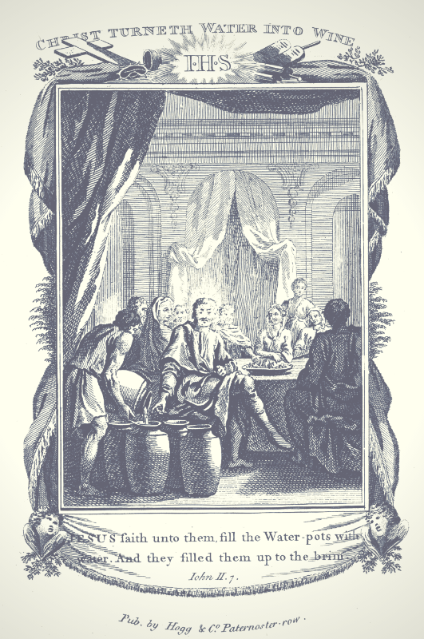
In Your Will and with Your Love, I desire to gather all that You have created out of so much love for mankind, from the beginning of time until the end of time; all souls, all Angels and all Creation, substituting for any and all who would refuse to join me. I bring all Your Creatures and Creation before Your Most Holy and Majestic Throne, and prostrating ourselves, we proclaim our love, adoration, praise, and honor, to glorify You profoundly, pleading through these rounds for Your Kingdom to come:

- In the desire of Jesus, who wants to make us into a copy of our Heavenly Mother
- In the seas of graces that inundated Mary at each instant
- In the favors and grace that passed between Mary and Jesus
- In the most important, most grand, most holy thing was known that the Son of God was her Son
- In the greatest honor bestowed on a human being, being the mother of God, which raised Her above all creatures
- In the sanctuary of the divine secrets

Volume 19, March 6, 1926

Continuing in Thy Will and with Thy Love, we love you, we adore you, and we glorify you:

- In the Heavenly Mother, who surpasses all creatures
- In Mary, who is the new heaven and the most brilliant sun
- In Mary, who encloses all goods together, because, gifted with reason and the Divine Will living integral within Her, the fullness of grace, of light, of sanctity, grew at each instant
- In the Will of God that was integral and permanent in Mary, which did the greatest thing and impetrated the longed-for Redeemer
- In the Mother of God, who is Queen in the midst of Creation
- In every fiber of Mary’s heart, word, thought which possessed the life of Jesus

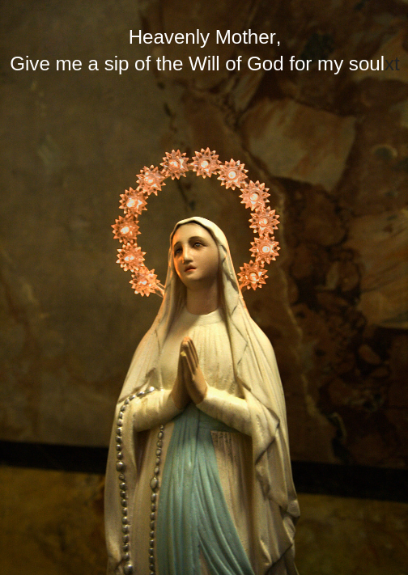
Volume 19, April 28, 1926

In Thy Will, with Thy Love, we love you, we adore you, and we praise you:

- In the Wedding at Cana in Galilee
- In the Mother of Jesus, Jesus, and the disciples who had been invited
- In the words of Mary, “They have no wine”
- In the words of Jesus, “Woman, why turn to me? My hour has not yet come.”
- “Do whatever He tells you”
- In the miracle of Jesus, who turns 6 stone water jars of water into wine
- In the words of the steward, “People generally serve the best wine first, and keep the cheaper sort till the guests have had plenty to drink; but you have kept the best wine till now”

The Jerusalem Bible

In Thy Will, with Thy Love, we love, adore, praise and glorify you:

- In the teaching that the Word became flesh to make us partakers of the divine nature
- In the Word that became man
- In the teaching that the Son of God became man so that we might become God
- In the only-begotten Son of God, who wants to make us sharers in his divinity, assumed our nature, so that he, made man, might make men gods

Catechism of the Catholic Church, 460

In Thy Will, with thy Love, we are so sorrowful, and we beg pardon:

- For the sins of the night, especially those committed by sectarians upon the Sacred Body of Jesus
- For the sins of souls who do not remain faithful in the night of the test

Hours of the Passion, 4 am Hour

Mother of Jesus, be a mother to me and guide me in the way of the Will of God

