The Passion and Cross

In Your Will and with Your Love, I desire to gather all that You have created out of so much love for mankind, from the beginning of time until the end of time; all souls, all Angels and all Creation, substituting for any and all who would refuse to join me. I bring all Your Creatures and Creation before Your Most Holy and Majestic Throne, and prostrating ourselves, we proclaim our love, adoration, praise, and honor, to glorify You profoundly, pleading through these rounds for Your Kingdom to come:

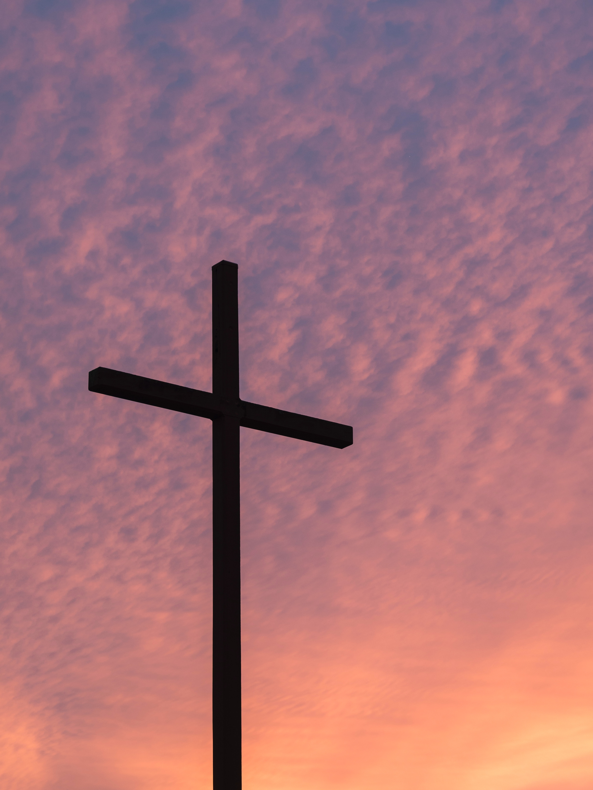
-In the act of Jesus’ enemies as they force Him back into the praetorium
-In being stripped of the purple mantle
-In the pain Jesus suffers when the crown of thorns is pulled from His head
-In every thorn that remains lodged in His head
-In the blood that runs down His face in little streams
-In Jesus’ second crowning of thorns
-In the thorns that enter His eyes, ears, and mouth
-In the pain Jesus experiences as He staggers under the cruel hands of His enemies
-In the act of embracing, kissing, and carrying the Cross
-In the pain Jesus experiences at His 1st fall
-In each step He takes as He carries the Cross
-In the painful meeting with His Mother
-In His 2nd fall under the Cross
-In the deep, painful wound of His shoulder that is caused by the heavy weight of the Cross
-In the act of Simon, the Cyrenian, who is forced to help Jesus bear the Cross
-In the act of Veronica as she fearlessly offers a cloth to wipe His Face
-In the consoling words to the pious women, “Do not weep for my suffering. Rather, weep for your sins and those of your children.”
-In the pain of the 3rd fall
-In the pain of being dragged to Mount Calvary
-In Jesus’ pain that He experiences when they tear off His garments and the crown of thorns
-In the suffering He endures as they place the crown of thorns on His Sacred Head for the third time

10 am Passion Hour

In Thy Will, with Thy Love, we love you, we adore you, and we praise you:

- In the words of the responsorial psalm, “My God, my God, why have you abandoned me?”
- “All who see me scoff at me; they mock me with parted lips, they wag their heads: ‘He relied on the Lord; let him deliver him, let him rescue him, if he loves him.’
- “Indeed, many dogs surround me, a pack of evildoers closes in upon me, they have pierced my hands and my feet; I can count all my bones
- “They divide my garments among them, and for my vesture they cast lots. But you, O Lord, be not far from me; O my help, hasten to aid me.
The Mass

In Thy Will, with Thy Love, we love, adore, praise and glorify you:

- In Christ, who “is the head of the body, the Church”
- In Christ, who is the principle of creation and redemption
- In Christ, who was raised to the Father’s glory
- In Christ, who is preeminent especially in the Church, through whom he extends his reign over all things

Catechism of the Catholic Church, 792

In Thy Will, with thy Love, we are so sorrowful, and we beg pardon:

- For those who despair of the Divine Mercy at the moment of death
- For all the offenses committed against the Virgin Mary
- For the blasphemies and the ingratitude of so many souls who do not want to acknowledge how much Jesus has blessed us by giving Mary to us to be our Mother

Hours of the Passion, 1 pm Hour

My Mother, triumph in my soul with your power and grant that I always remain in the Will of God

