The Shepherd and His Sheep

In Your Will and with Your Love, I desire to gather all that You have created out of so much love for mankind, from the beginning of time until the end of time; all souls, all Angels and all Creation, substituting for any and all who would refuse to join me. I bring all Your Creatures and Creation before Your Most Holy and Majestic Throne, and prostrating ourselves, we proclaim our love, adoration, praise, and honor, to glorify You profoundly, pleading through these rounds for Your Kingdom to come:

- In the manifestation of Jesus to Luisa holding many small sheep in his arms
- In the sheep that rested on His breast, on His shoulders, wrapped around His neck, in His arms to His right and to His left and to the others that thrust their little heads out of His Heart
- In the feet of all these sheep that rested in the heart of Jesus
- In the enjoyment and delight that Jesus takes in these sheep who are His children, the newly born from His Most Sacred Heart

Volume 14, November 6, 1922

Continuing in Thy Will and with Thy Love, we love you, we adore you, and we glorify you:

- In the legitimate offspring of the Supreme Will
- In the souls who take nothing of the earth and who are not concerned about anything other than Jesus
- In these souls who will be the glory and the crown of all Creation
- In the desire of Jesus who wants the living in the Divine Will to be known

Volume 14, November 6, 1922

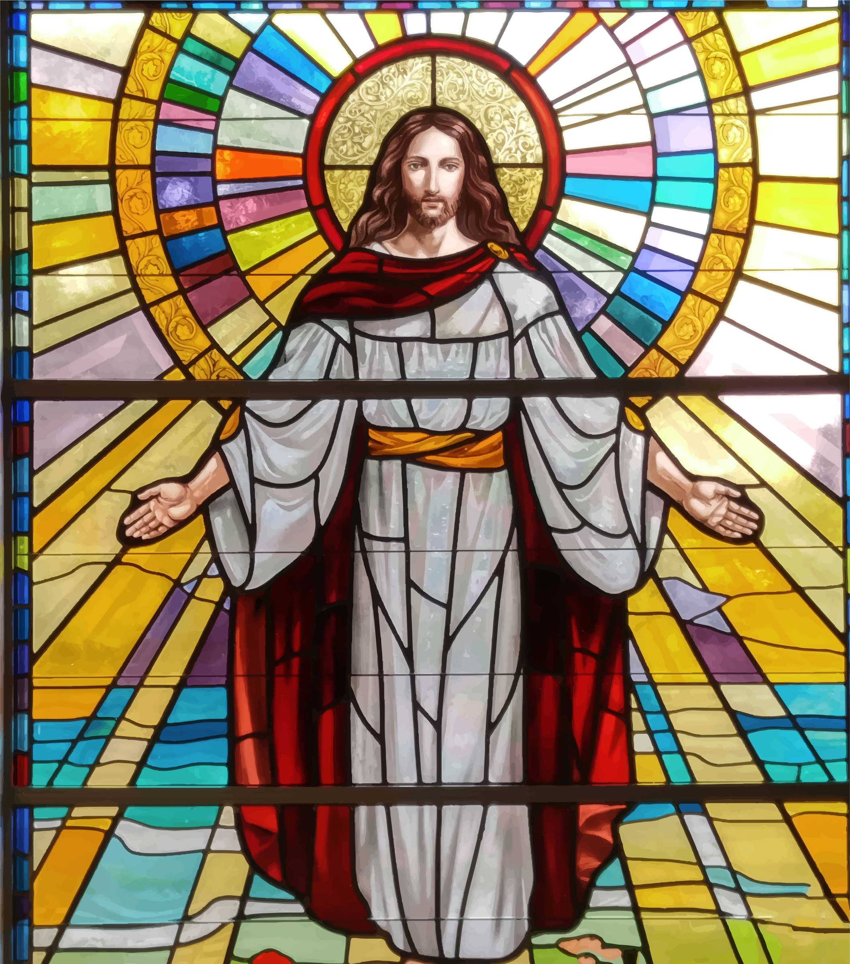

In Thy Will, with Thy Love, we love you, we adore you, and we praise you:

- In the words, “I am the good shepherd: the good shepherd is one who lays down his life for his sheep”
- “I am the good shepherd; I know my own and my own know me, just as the Father knows me and I know the Father”
- “They will never hunger of thirst again; neither the sun not scorching wind will ever plague them because the Lamb who is at the throne will be their shepherd and will lead them to springs of living water; and God will wipe away all tears from their eyes”

The Jerusalem Bible

In Thy Will, with Thy Love, we love, adore, praise and glorify you:

- In the Church which will receive its perfection only in the glory of heaven, at the time of Christ’s glorious return.

Catechism of the Catholic Church, 769

In Thy Will, with thy Love, we are so sorrowful, and we beg pardon:

- For those who allow the love of parents, friends, ties, and attachments, to keep them from fulfilling God’s Holy Will and from reaching the level of sanctity to which God calls them
- For those who refuse to surrender to Jesus – in spite of sorrows and disappointments of life
- For many souls consecrated to Jesus – souls whom He tried to form patiently into radiant vessels of Love, but whose ingratitude and coldness makes Him suffer bitterly

Hours of the Passion, 6 pm Hour

Holy Mother, grant me to lose my will forever to live
In the Divine Will

